**Project Design Phase-II**

**Data Flow Diagram & User Stories**

|  |  |
| --- | --- |
| Date | 25 October 2022 |
| Team ID | PNT2022TMID52015 |
| Project Name | Real-Time Communication System Powered by AI For Specially Abled. |
| Maximum Marks | 4 Marks |

**Data Flow Diagrams:**

A Data Flow Diagram (DFD) is a traditional visual representation of the information flows within a system. A neat and clear DFD can depict the right amount of the system requirement graphically. It shows how data enters and leaves the system, what changes the information, and where data is stored.

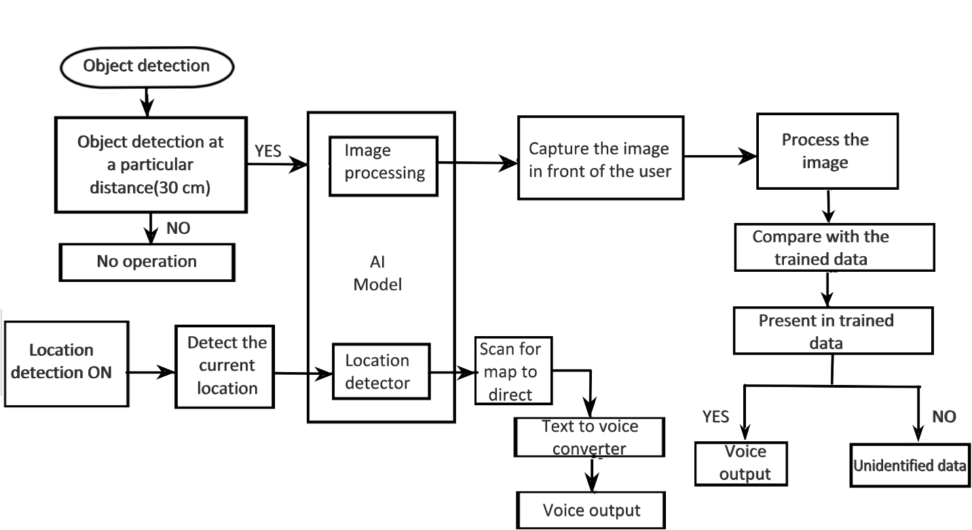

Here the device detects the object and if the object is detected at a particular distance of 30 cm, image processing takes place by capturing ,processing and comparing the detected image with the trained data. If the image is present in the trained data, then the device provides the output in the form of a voice signal. If the image does not match with the trained data, then the device gives the output as unidentified data. The location detector in the AI model is used to detect the current location of the user and provide the data in the form of a voice signal.

**User Stories**

Use the below template to list all the user stories for the product.

| **User Type** | **Functional Requirement (Epic)** | **User Story Number** | **User Story / Task** | **Acceptance criteria** | **Priority** | **Release** |
| --- | --- | --- | --- | --- | --- | --- |
| Customer (Mobile user) | Registration | USN-1 | As a user, I can register for the application by entering my email, password, and confirming my password. | I can access my account / dashboard | High | Sprint-1 |
|  |  | USN-2 | As a user, I will receive confirmation email once I have registered for the application | I can receive confirmation email & click confirm | High | Sprint-1 |
|  |  | USN-3 | As a user, I can register for the application through Gmail. | I can receive verification code and invitation | Medium | Sprint-1 |
| Administrator | Login | USN-4 | As a user, I can log into the application by entering email & password | I can login to my account | High | Sprint-1 |
| Customer service | Training data (dashboard) | USN-5 | Ask for the trained data to be added. | I am adding the trained data to get the image recognized. | High | Sprint-1 |
| Customer | Object detection | USN-6 | Detecting the object within 30 cm distance. | I can sense any objects that are at a distance of 30 cm. | High | Sprint-2 |
| Customer | Location detection | USN-7 | Detecting the location in the map. | I can set the destination to be reached. | High | Sprint-2 |
| Customer service | Capture the image | USN-8 | Captures the image and detects the image using image processing. | I can check for the image in trained data | High | Sprint-3 |
| Customer service | Location fix | USN-9 | The path will be fixed. | I can know the direction which will be given as voice output. | High | Sprint-4 |
| Customer service | Person/Object fix | USN-10 | The name of the person or the object is detected. | I can get a voice output if the name is registered in the trained data. | High | Sprint-4 |